Programming Concepts  
Week 7 **Credit** Submission Tasks Template

Student ID: ________Mario Stavreski_____________

Student Name: __________103055993____________________

## Credit Task 8 HTML code

Paste the HTML code of the web page here.

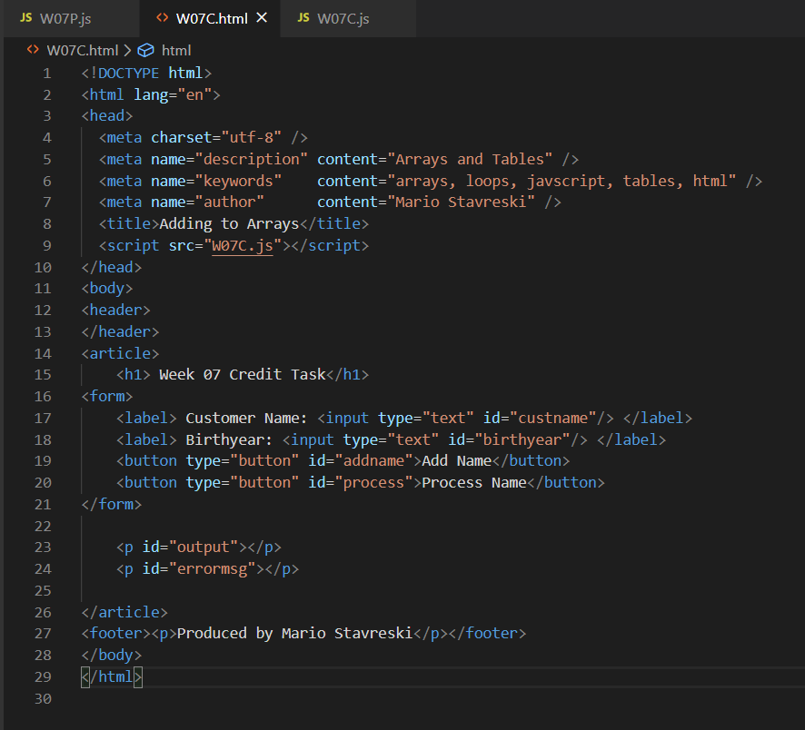

## Credit Task 8 JavaScript code

Paste the JavaScript code of the same page here.

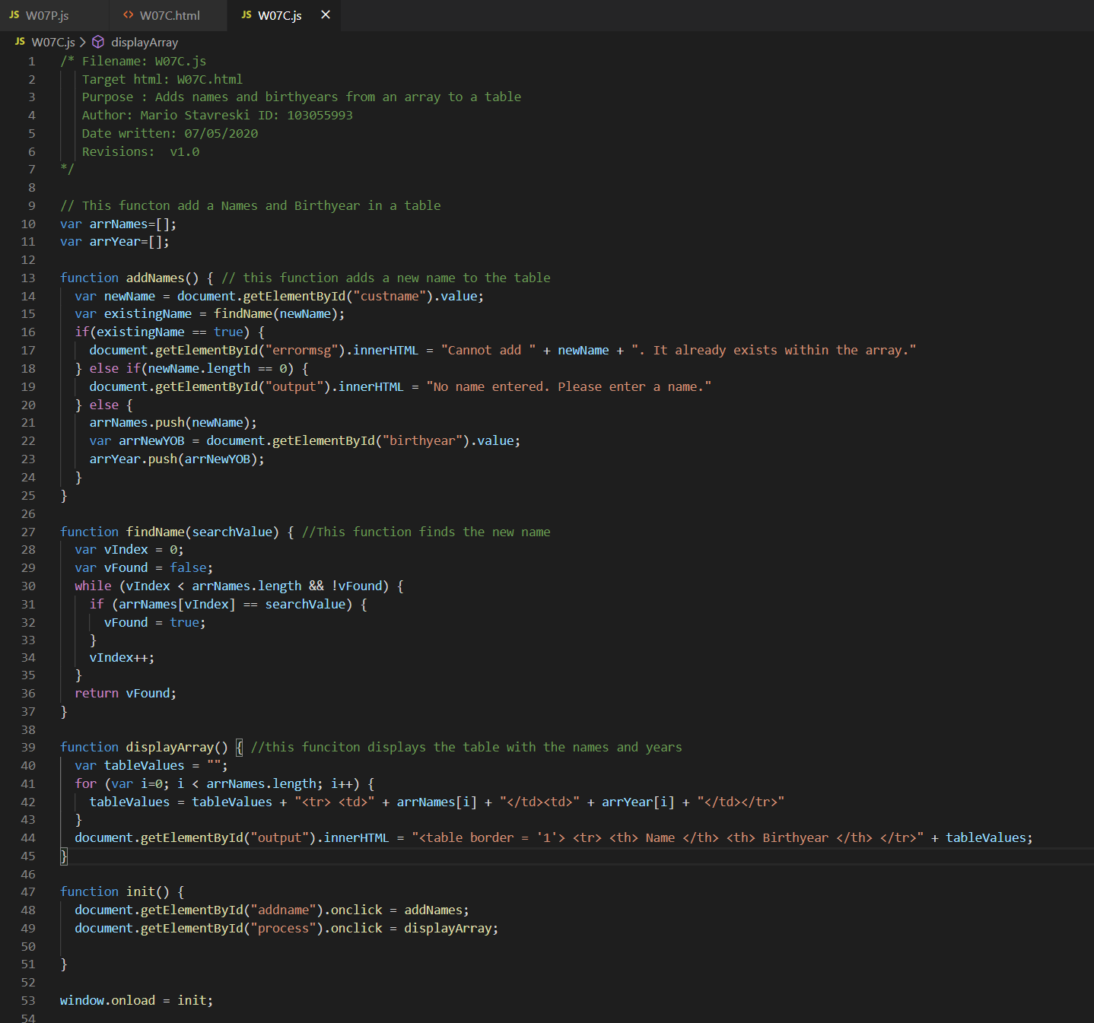

## Credit Task 8 web page testing (screenshots should demonstrate all error messages, including invalid user inputs, attempting to List All Items when arrays are empty and when there are some items in the arrays)

Paste the screen captures of your testing web page here.

